JAVA VITYARTHI PROJECT

FALL SEMESTER 2026-27

Name: Goranshi Agarwal

Registration Number: 25BAI11505

Program: B.Tech Computer Science and Engineering (AI & ML)

Year: 2nd Year

PROJECT TITLE:

DIGITAL FOOTPRINT ANALYZER & PRIVACY RISK ASSESSMENT SYSTEM

1. Introduction
Today, we use the internet and social media for almost everything. We create accounts, share photos, communicate with others, use different apps, and often share information without thinking much about it. All this information becomes part of our digital footprint.
A digital footprint can include things like usernames, photos, email addresses, phone numbers, location, and other personal details. If too much of this information is publicly available, it can create privacy and security risks.
The Digital Footprint Analyzer & Privacy Risk Assessment System was developed to help users understand these risks. The application asks simple questions about their online habits and uses the answers to calculate a privacy risk score. It also provides recommendations to help users improve their privacy.

2. Problem Statement
Many users are not aware of how much personal information they are sharing online or which of their habits may create privacy risks.
The purpose of this project is to develop a simple system that can:
- Analyze common online privacy habits.
- Calculate an overall privacy risk score.
- Identify the main areas where risk exists.
- Provide useful recommendations.
- Help users track their privacy results over time.

3. Objectives
The main objectives of this project are:
- To develop an easy-to-use privacy assessment system.
- To identify common digital privacy risks.
- To calculate risk and privacy scores.
- To provide personalized recommendations.
- To show how certain privacy improvements can affect the risk score.
- To maintain a local history of previous assessments.
- To create awareness about digital privacy.

4. Project Scope
The current project works as a privacy self-assessment tool.
The user answers questions about their online habits, and the system analyzes the answers. It does not automatically scan social media accounts or search the internet for personal information.
The application also does not ask users to enter passwords, OTPs, or account login details. This keeps the assessment simple and avoids collecting sensitive credentials.

5. Technologies Used
Technology | Purpose
Java | Main programming language
Java Swing | Creating the graphical interface
CardLayout | Moving between different screens
File Handling | Saving and reading data
CSV | Storing assessment history
The project uses standard Java and does not require external libraries.

6. System Workflow
The basic working of the application is:
User Input → Privacy Assessment → Risk Calculation → Risk Level → Recommendations → Report
First, the user completes the assessment. The system then processes the answers, calculates the risk for different categories, and generates the final result.

7. Privacy Assessment
The assessment contains questions related to the user's online activities and privacy habits.
The system considers:
- Number of public social profiles
- Use of the same username on different platforms
- Unknown followers
- Identifiable photos
- Public email address
- Public phone number
- Public birthday
- Public education details
- Location sharing
- Live location sharing
- Public travel plans
- Password reuse
- Two-factor authentication
- Privacy settings review
- Unused accounts
- App permissions
The user provides only the information needed for the assessment and does not enter actual account credentials.

8. Risk Categories
The system divides the assessment into six categories.

8.1 Social Media Exposure
This category looks at public social media activity, including public profiles, usernames, followers, and identifiable photos.

8.2 Account Security
This category focuses on password reuse and the use of two-factor authentication.

8.3 Location Privacy
This category considers location sharing, live location sharing, and public travel plans.

8.4 Personal Information
This category covers personal details such as email, phone number, birthday, and education information.

8.5 Account Hygiene
This category looks at unused or old online accounts.

8.6 App Privacy
This category considers the permissions given to applications.

9. Risk Calculation
Each risk category has a different weight in the final calculation.
Category | Weight
Social Media Exposure | 20%
Account Security | 25%
Location Privacy | 20%
Personal Information | 15%
Account Hygiene | 10%
App Privacy | 10%
The category scores are combined according to these weights to calculate the overall risk score.
The privacy score is calculated using:
Privacy Score = 100 − Risk Score
For example, if the risk score is 60, the privacy score will be 40.

10. Risk Levels
The final risk score is converted into a simple risk level.
Score | Risk Level
0–20 | LOW
21–40 | MODERATE
41–60 | MEDIUM
61–80 | HIGH
81–100 | CRITICAL
This makes the result easier to understand instead of showing only a number.

11. Recommendation System
After calculating the result, the application gives recommendations based on the user's answers.
For example, the system may suggest:
- Enable two-factor authentication.
- Avoid using the same password on multiple accounts.
- Review social media privacy settings.
- Reduce unnecessary location sharing.
- Limit personal information visible to the public.
- Review app permissions.
- Check unused accounts.
The recommendations are generated using predefined rules in the application.

12. Dashboard and Report
The dashboard provides a quick summary of the assessment.
It shows:
- Risk score
- Privacy score
- Risk level
- Category-wise results
- Recommendations
The application also provides a detailed report that gives more information about the assessment. The report can be exported as a text file for future reference.

Dashboard screenshots:
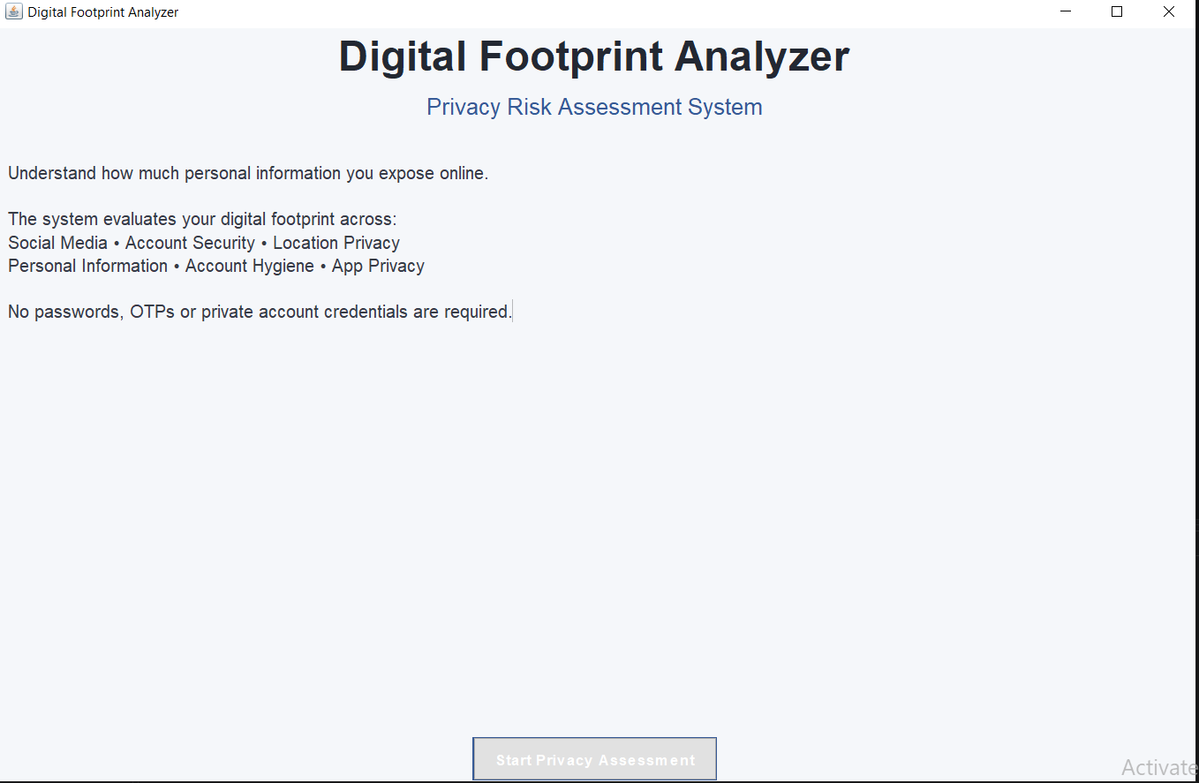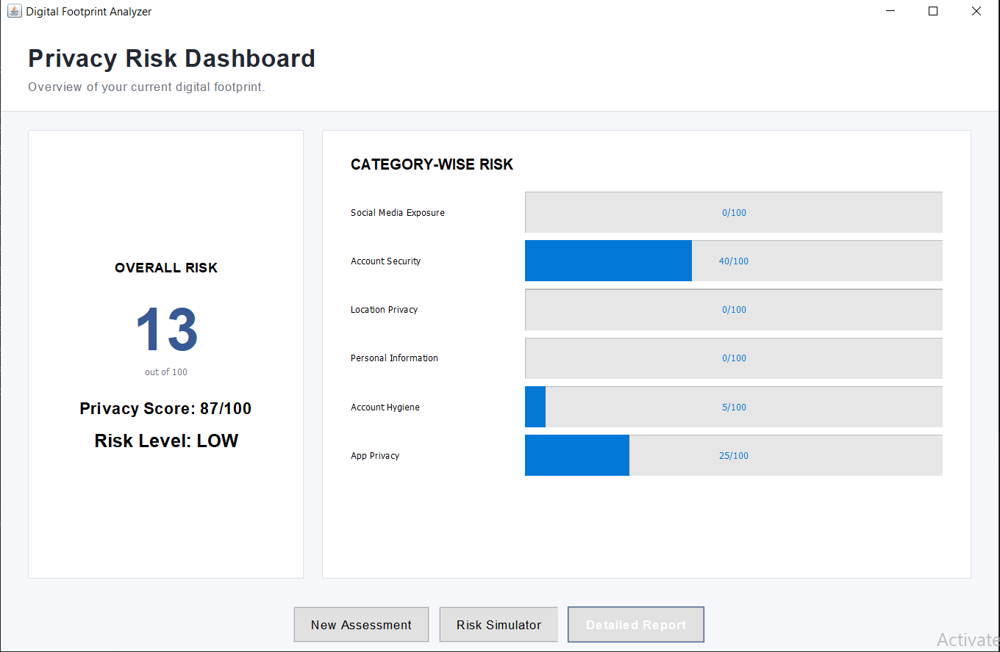

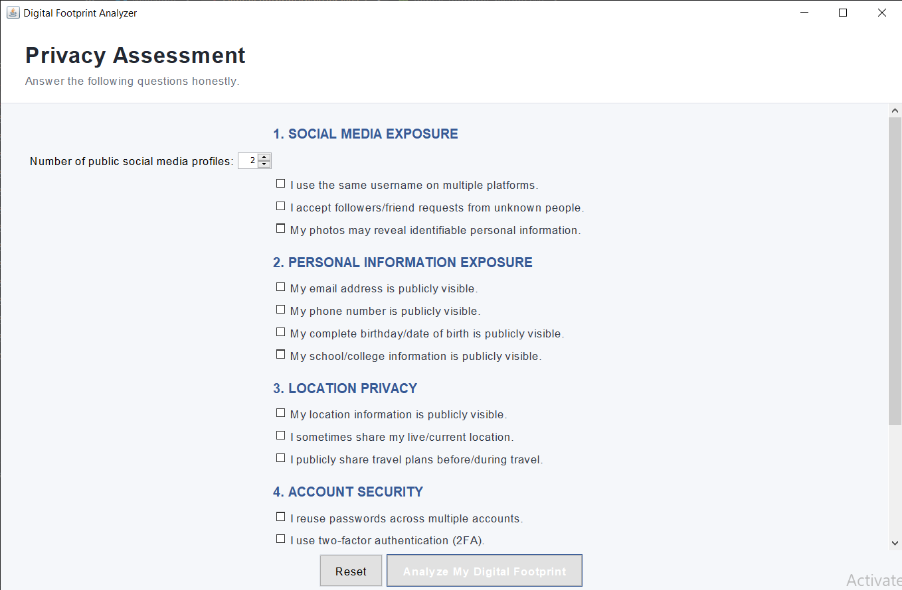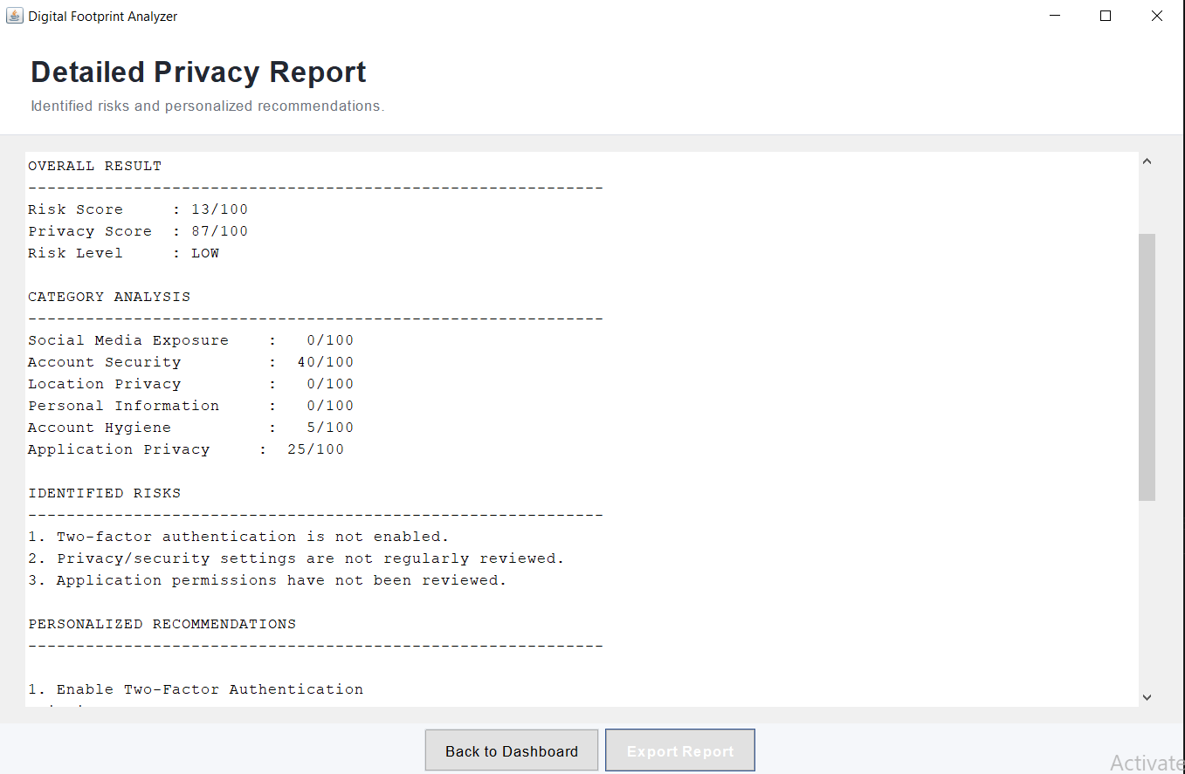

13. Assessment History
The application saves previous assessment summaries in a local CSV file.
The stored information includes:
- Date
- Risk score
- Privacy score
- Risk level
This allows users to compare their results over time and see whether their privacy habits are improving.

14. Risk Simulator
The Risk Simulator allows users to test possible privacy improvements without changing their original assessment.
For example, users can simulate:
- Enabling two-factor authentication
- Stopping location sharing
- Hiding a public phone number
- Stopping password reuse
The system then calculates the simulated risk score.
This feature helps users understand how different privacy actions can affect their overall result.

15. Privacy Education
The application also contains a small educational section about digital privacy.
It covers topics such as:
- Digital footprints
- Password security
- Two-factor authentication
- Social media privacy
- Location privacy
- App permissions
This section helps users understand the reason behind some of the recommendations given by the application.

16. Testing
The main features of the application were tested using different inputs.
Test Case | Expected Result
Launch application | Welcome screen appears
Start assessment | Assessment screen opens
Complete assessment | Risk score is calculated
View dashboard | Assessment results are displayed
View report | Detailed result is shown
Generate recommendations | Relevant suggestions appear
Save assessment | History is updated
Open simulator | Simulation options are displayed
Export report | Text report is created
The testing was used to check the main screens, calculations, recommendations, history, simulator, and report export functionality.

17. Limitations
The current version of the project has some limitations:
- It does not automatically scan online platforms.
- It does not connect to social media APIs.
- It uses predefined rules instead of machine learning.
- The result depends on the information provided by the user.
- Assessment history is stored locally using CSV.
These limitations can be addressed in future versions.

18. Future Scope
The project can be further improved by adding:
- Machine learning-based risk analysis.
- Database support.
- Web and mobile versions.
- Integration with legitimate APIs for automated analysis.
- Graphs and more detailed analytics.
- Privacy reminders.
- More advanced risk calculations.

19. Project Structure
Digital-Footprint-Analyzer/

DigitalFootprintAnalyzer.java
digital_footprint_history.csv
README.md
Screenshot

The main application is contained in
- DigitalFootprintAnalyzer.java.

20. How to Run the Project
A compatible Java Development Kit (JDK) is required.
Open the project folder and compile the program using:
javac DigitalFootprintAnalyzer.java
Then run it using:
java DigitalFootprintAnalyzer
The application will open with the welcome screen.

21. Conclusion

The Digital Footprint Analyzer & Privacy Risk Assessment System is a simple application designed to help users understand their online privacy habits.
The system collects information through a questionnaire, analyzes the answers using predefined rules, and provides a risk score, privacy score, risk level, and recommendations.
Features such as the dashboard, assessment history, detailed report, privacy education, and risk simulator make the application more useful and interactive.
The project also follows a privacy-friendly approach by not asking users for passwords, OTPs, or account credentials.
Overall, this project combines Java programming, GUI development, file handling, rule-based decision making, and digital privacy awareness into one practical application.

22. Declaration
I hereby declare that the project titled “Digital Footprint Analyzer & Privacy Risk Assessment System” has been developed as part of my academic project work.
The project has been developed using Java and Java Swing and focuses on assessing common digital privacy habits using a rule-based risk assessment system.
Name: Goranshi Agarwal

